**Chapter**

**System Testing**

System testing for a virtual telepresence robot involves evaluating the overall functionality, performance, and reliability of the system as a whole. It aims to ensure that the robot meets the specified requirements and operates correctly in various scenarios.

The goal of system testing is to validate the system's compliance with functional and non-functional requirements, its behavior under various scenarios, and its ability to deliver the desired functionality to end users. It aims to identify defects, errors, and inconsistencies that may arise due to interactions between different components or modules within the system.

**Testing of Robot movement controls.**

|  |  |  |  |
| --- | --- | --- | --- |
| **Sl No.** | **Test Case** | **Expected Outcome** | **Result** |
| 1 | Press forward button | Move forward | Pass |
| 2 | Press Backward button | Move backward | Pass |
| 3 | Press left button | Move left | Pass |
| 4 | Press right button | Move right | Pass |

**Testing of video streaming according to user’s VR head set movement.**

|  |  |  |  |
| --- | --- | --- | --- |
| **Sl. No** | **Test Case** | **Expected Outcome** | **Result** |
| 1 | Head movement – up | Camera movement - up | Pass |
| 2 | Head movement – down | Camera movement–down | Pass |
| 3 | Head movement – left | Camera movement – left | Pass |
| 4 | Head movement – right | Camera movement- right | Pass |

**Testing of power supply**

|  |  |  |  |
| --- | --- | --- | --- |
| **Sl. No** | **Test Case** | **Expected Outcome** | **Result** |
| 1 | Supply power | charged | Pass |
| 2 | Stop power supply | Stops charging | Pass |

**Testing of voltage regulator**

|  |  |  |  |
| --- | --- | --- | --- |
| **Sl. No** | **Test Case** | **Expected Outcome** | **Result** |
| 1 | Regulate the voltage to 5 volts | Robot receives 5volts | Pass |
| 2 | Receive power supply from battery | Voltage regulator receives power | Pass |

**Testing of Raspberry Pi**

|  |  |  |  |
| --- | --- | --- | --- |
| **Sl. No** | **Test Case** | **Expected Outcome** | **Result** |
| 1 | Receiving input from Bluetooth module and direct it to DC motors | Movement of robot | Pass |
| 2 | Implementation of Object detection programme in SD card | Object detection visuals displayed by Pi camera | Pass |

**Chapter**

**Result**

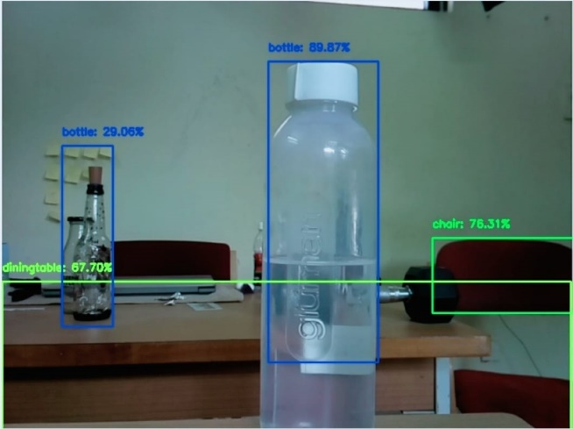

**Chapter**

**Conclusion and Future Enhancement**

**Conclusion**

Integrating features of all the hardware components used have been developed in it. Presence of every module has been reasoned out and placed carefully, thus contributing to the best working of the unit. Secondly, using highly advanced IC’s with the help of growing technology, the project has been successfully implemented. Thus the project has been successfully designed and tested.

Future Enhancement